PROJECT REPORT
on
NETWORK PACKET ANALYZER
A Web-Based Tool for Capturing, Analyzing and Visualizing Network Traffic
Submitted by
Priyanshu
Bachelor of Computer Applications (BCA)
Department of Computer Applications
Maharishi Dayanand University

Table of Contents

1. Abstract
This project presents the design and implementation of a Network Packet Analyzer, a web-based application that enables users to capture, process, and visualize network traffic data. Packets are captured using Wireshark, exported in a structured format, and then processed using Python's Pandas library to extract meaningful statistics such as protocol distribution, source–destination communication patterns, and traffic volume over time. A Flask-based backend serves this processed data to an interactive web dashboard built with HTML, CSS, and Chart.js, allowing users to visualize network behaviour through dynamic charts and tables. The application also supports uploading custom .csv packet-capture files for offline analysis, making it a flexible tool for cybersecurity students, network administrators, and enthusiasts who want to study traffic patterns without relying solely on Wireshark's native interface. The completed application was deployed and tested on Replit, demonstrating that a lightweight, browser-accessible packet analysis tool can be built using open-source technologies.

2. Introduction

2.1 Background
Network traffic analysis is a fundamental skill in cybersecurity, network administration, and digital forensics. Tools such as Wireshark provide deep, packet-level visibility into network communication, but their output can be dense and difficult to interpret for beginners, and they are not naturally suited to being shared or visualized as a web dashboard. There is a need for lightweight tools that take raw packet data and translate it into clear, visual insights that can be accessed through a browser.

2.2 Problem Statement
Analyzing raw packet captures manually inside Wireshark can be time-consuming, and the results are not easily shareable or presentable in a summarized, visual form. There was a need for a simple system that could take exported packet data, process it programmatically, and present the results through an accessible, interactive web interface.

2.3 Objectives
- To capture live network packets using Wireshark and export them in a structured format (CSV/PCAP).
- To process and analyze the exported packet data using Python and Pandas.
- To build a Flask-based backend that serves processed data to a web dashboard.
- To design an interactive, visually clear frontend using HTML, CSS, and Chart.js.
- To allow users to upload their own .csv packet files for custom traffic inspection.
- To deploy the completed application online using Replit for easy access and demonstration.

3. Tools and Technologies Used
Category | Technology / Tool
Packet Capture | Wireshark
Backend Framework | Python (Flask)
Data Processing | Pandas
Frontend | HTML, CSS, Chart.js
Hosting / Deployment | Replit
Programming Language | Python, JavaScript

3.1 Why These Tools?
- Wireshark: industry-standard, free, and reliable tool for capturing and exporting real network packets.
- Flask: a lightweight Python web framework, ideal for quickly building and serving a data-driven dashboard.
- Pandas: powerful and efficient library for cleaning, filtering, and aggregating packet data.
- Chart.js: simple JavaScript charting library that renders responsive, interactive visualizations in the browser.
- Replit: enables fast, browser-based deployment without needing dedicated server infrastructure.

4. System Architecture
The system follows a simple three-layer architecture consisting of a data capture layer, a processing/backend layer, and a presentation layer, described below.

4.1 Architecture Flow
- Packet Capture: Network traffic is captured using Wireshark and exported as a .csv (or .pcap converted to .csv) file.
- Data Upload/Ingestion: The exported file is either placed in the project directory or uploaded by the user through the web dashboard.
- Data Processing: The Flask backend uses Pandas to read the CSV, clean the data, and compute statistics (protocol counts, top talkers, packet sizes, traffic over time).
- API/Route Layer: Flask routes expose the processed data as JSON to the frontend.
- Visualization: The HTML/CSS frontend, using Chart.js, fetches this JSON data and renders it as interactive charts and tables.
- Deployment: The complete application is hosted on Replit, making it accessible via a shareable web link.

4.2 High-Level Diagram (Textual)
Wireshark (Packet Capture) → CSV Export → Flask Backend + Pandas (Processing) → JSON API → HTML/CSS + Chart.js Dashboard (Visualization) → Deployed on Replit

5. Modules / Implementation Details

5.1 Packet Capture Module
Uses Wireshark to capture live network traffic on a selected interface. Captured packets are filtered as needed and exported in .csv format, containing fields such as timestamp, source IP, destination IP, protocol, and packet length.

5.2 Data Processing Module (Pandas)
The Flask backend reads the CSV file into a Pandas DataFrame. This module performs cleaning (handling missing/duplicate entries), computes protocol-wise packet counts, identifies the most active source and destination IP addresses, and aggregates traffic volume across time intervals.

5.3 Web Dashboard Module (Flask + HTML/CSS)
Flask serves the main dashboard page and exposes REST-style routes that return processed statistics as JSON. The frontend, built with HTML and CSS, presents this data in a clean, organized layout with cards, tables, and chart containers.

5.4 Visualization Module (Chart.js)
Chart.js is used to render protocol distribution as pie/bar charts and traffic-over-time as line charts, giving users an immediate visual understanding of network behaviour.

5.5 File Upload Module
Users can upload their own .csv packet-capture files through the dashboard. The uploaded file is processed using the same Pandas pipeline, allowing analysis of traffic data captured on other networks or at other times.

5.6 Deployment Module (Replit)
The complete Flask application, along with its dependencies, is deployed on Replit, allowing the analyzer to be accessed directly through a browser without local installation.

6. Screenshots
The following screenshot shows the web dashboard, including the CSV upload option and the interactive charts for Top Source IPs and Top Protocols.

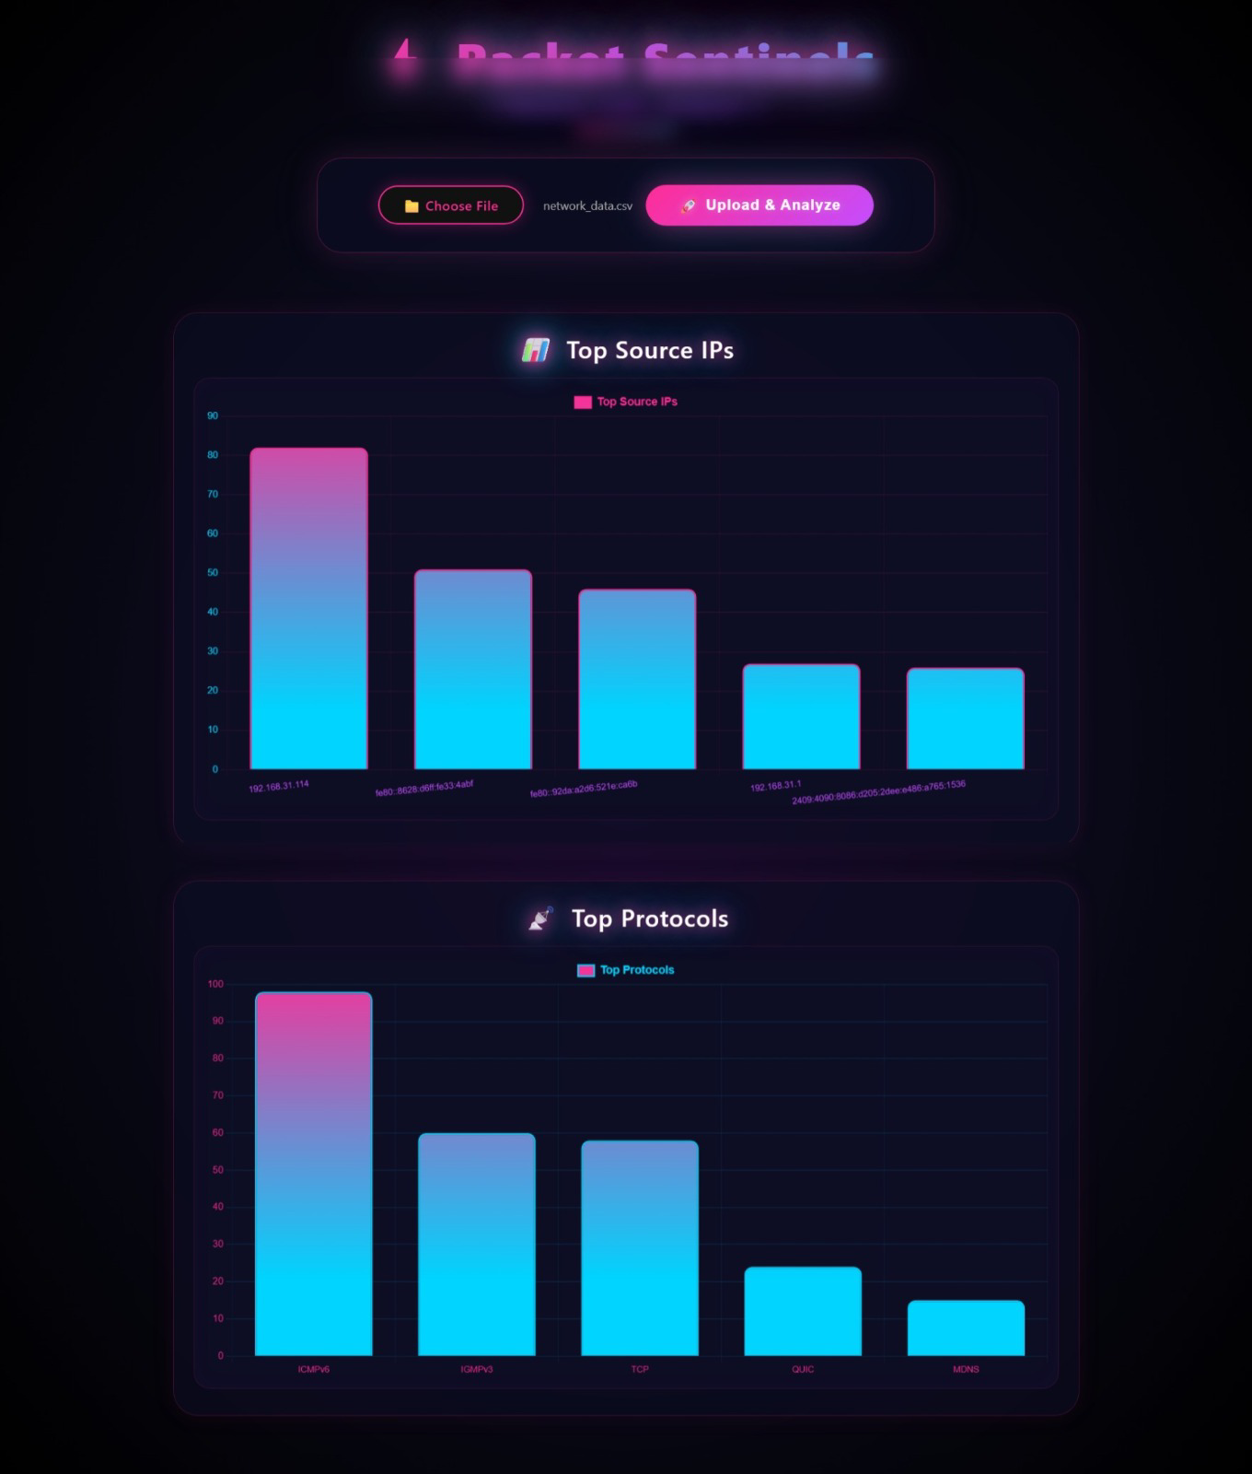
Fig 6.1: Dashboard showing file upload and traffic visualization charts (Top Source IPs, Top Protocols).
Screen | Description
Dashboard Home / Upload | Interface to choose and upload a packet-capture CSV file and trigger analysis.
Top Source IPs Chart | Bar chart showing the IP addresses generating the most traffic in the capture.
Top Protocols Chart | Bar chart showing the distribution of protocols (e.g., ICMPv6, IGMPv3, TCP, QUIC, MDNS) observed in the capture.

7. Results and Discussion
The application successfully captures exported Wireshark packet data and presents it through an interactive dashboard. Users are able to quickly identify the dominant protocols in a capture, the most active hosts, and traffic trends over time — insights that would otherwise require manual filtering within Wireshark itself. The CSV upload feature was tested with multiple sample captures and correctly processed varying file sizes and formats. The deployed Replit instance was accessible and functioned correctly in a browser environment without additional local setup.

8. Advantages and Limitations

8.1 Advantages
- Simple, browser-based interface — no need to interpret raw Wireshark output directly.
- Reusable: any exported CSV capture can be uploaded and analyzed.
- Lightweight and easy to deploy using free platforms like Replit.
- Clear visual insights using charts rather than raw tabular data.
- Useful learning tool for understanding protocols and traffic patterns.

8.2 Limitations
- Relies on Wireshark for actual live packet capture; the web app itself does not sniff packets directly.
- Large CSV files may take longer to process depending on server resources on Replit.
- Currently supports analysis of exported data rather than true real-time live streaming into the dashboard.

9. Future Scope
- Integrate live packet sniffing directly within the Flask app using libraries such as Scapy or PyShark.
- Add user authentication to support multiple users and saved analysis history.
- Introduce anomaly/intrusion detection using basic machine learning models on traffic patterns.
- Support exporting analysis reports as PDF directly from the dashboard.
- Deploy on a more scalable cloud platform for handling larger capture files.

10. Conclusion
The Network Packet Analyzer project demonstrates how open-source tools such as Wireshark, Python (Flask), and Pandas can be combined with simple web technologies to build a practical, accessible network analysis tool. By translating raw packet captures into interactive visualizations, the project makes network traffic analysis more approachable for students and cybersecurity enthusiasts. The project also provided hands-on experience in packet capture, data processing, backend web development, frontend visualization, and application deployment — covering the full pipeline from raw data to a usable, deployed web application.

11. References
- Wireshark Official Documentation — https://www.wireshark.org/docs/
- Flask Official Documentation — https://flask.palletsprojects.com/
- Pandas Official Documentation — https://pandas.pydata.org/docs/
- Chart.js Official Documentation — https://www.chartjs.org/docs/
- Replit Documentation — https://docs.replit.com/

